Index Operator
Just like strings, the elements in a list are 0 indexed, meaning that the first element is at index 0, second is at 1, third is at 2 and so on. The last valid index will be one less than the length of the list. We use the following syntax to access an element from the list.
a_list[index]
where index must be an integer.
For example, the following statement creates a list of 6 elements.
list1 = [88, 99, 4.12, 199, 993, 9999]
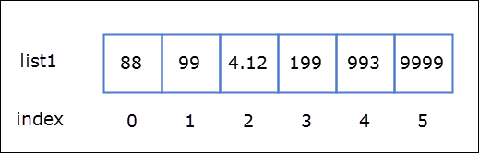
Here list1[0] refers to the element 88, list1[1] refers to 99 and list[5] refers to 9999.
1  2  3  4  5  6  7  8  9  10 | >>>  >>> list1 = [88, 99, 4.12, 199, 993, 9999]  >>>  >>> list1[0] # get the first element  88  >>> list1[1] # get the second element  99  >>> list1[5] # get the sixth element  9999  >>>
Try it now
We can also calculate the last valid index of a list using the len() function, as follows:
1  2  3  4  5  6  7 | >>>  >>> len(list1) - 1  5  >>>  >>> list1[len(list1) - 1] # get the last element  9999  >>>
Try it now
Trying to access a element beyond the last last valid index will result in IndexError.
1  2  3  4  5  6  7 | >>>  >>> list1[100] # get the element at index 100  Traceback (most recent call last):  File "<stdin>", line 1, in <module>  IndexError: list index out of range  >>>  >>>
Try it now
Just like strings, negative indexes are still valid here. In fact we can use can negative index on almost all types of sequences in Python.
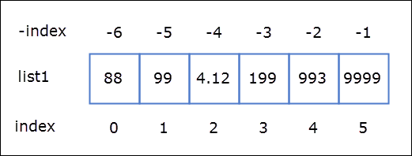
As you can see from the image the last element is at index -1, the second last element is at -2 and so on. The first element is at index -6.
1  2  3  4  5  6  7  8  9 | >>>  >>> list1  [88, 99, 4.12, 199, 993, 9999]  >>>  >>> list1[-1] # get the last element  9999  >>> list1[-2] # get the second last element  993  >>>
Try it now
To calculate the index of the first element use len() function as follows:
1  2  3  4 | >>>  >>> list1[-len(list1)] # get the first element  88  >>>

